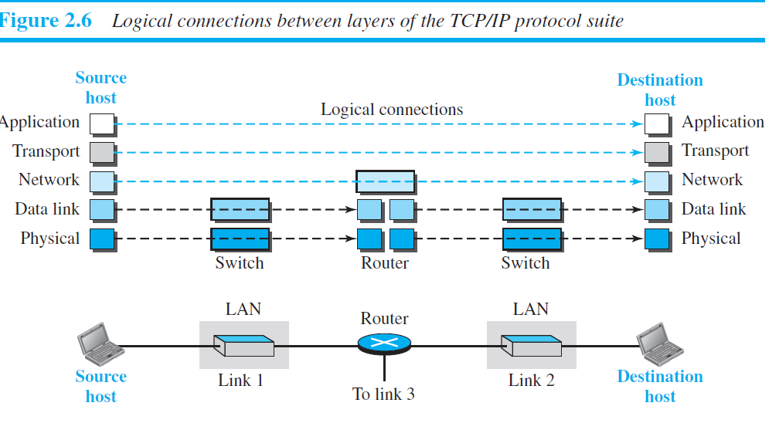

Application Layer
- Logical End-to-End Communication:
The application layers on two devices communicate directly as if connected by a logical bridge, even though data travels through all the underlying layers.
- Process-to-Process Communication:
Communication happens between processes (programs) running on different hosts. One process sends a request, and the other responds. Ensuring this interaction is the main role of the application layer.
- Standard Application Layer Protocols:
  - HTTP (Hypertext Transfer Protocol): Used for accessing the World Wide Web.
  - SMTP (Simple Mail Transfer Protocol): Used for sending email messages.
  - FTP (File Transfer Protocol): Used to transfer files between hosts.
  - TELNET (Terminal Network): Allows remote login to another host.
  - SSH (Secure Shell): Secure alternative to TELNET for remote access.
  - SNMP (Simple Network Management Protocol): Used for managing network devices.
  - DNS (Domain Name System): Translates domain names to IP addresses.
  - IGMP (Internet Group Management Protocol): Manages membership in multicast groups.
- Custom Applications:
Besides standard protocols, users can develop and run custom processes on two hosts to achieve communication.

Ports and Port Numbers in the Transport Layer

1. Introduction
In computer networking, ports and port numbers are essential concepts used in the Transport Layer (Layer 4 of the OSI model). They allow the operating system to distinguish between different network services and processes running on a host.

2. What is a Port?
A port is a logical communication endpoint within a host. It is used to identify specific applications or services. Just as an IP address identifies a host, a port number identifies a particular process on that host.

3. What is a Port Number?
A port number is a 16-bit integer (ranging from 0 to 65535) that identifies a port. When a networked device sends data to another device, it uses both the destination IP address and the destination port number to reach the correct process.

4. Port Number Ranges
Port numbers are categorized into three ranges by IANA:
Range | Type | Usage
0 – 1023 | Well-Known Ports | Assigned to common protocols (e.g., HTTP, FTP)
1024 – 49151 | Registered Ports | Used by specific applications or vendors
49152 – 65535 | Dynamic/Private Ports | Used by client applications dynamically

5. How Port Numbers Work
When a client (like a web browser) initiates communication, it uses a random port from the dynamic range and contacts the server on a well-known port (e.g., 80 for HTTP). The transport layer adds source and destination port numbers to the segment so that the data reaches the correct application.

6. Common Port Numbers
Protocol | Full Form | Port Number | Transport Protocol
HTTP | HyperText Transfer Protocol | 80 | TCP
HTTPS | HTTP Secure | 443 | TCP
FTP | File Transfer Protocol | 20 (data), 21 (control) | TCP
SMTP | Simple Mail Transfer Protocol | 25 | TCP
DNS | Domain Name System | 53 | UDP (TCP sometimes)
TELNET | Terminal Network | 23 | TCP
SSH | Secure Shell | 22 | TCP

7. Port Numbers in TCP/UDP Headers
Both TCP and UDP headers contain source and destination port numbers. These ensure that data reaches the correct application.
• TCP: Provides reliable, connection-oriented communication.
• UDP: Provides unreliable, connectionless communication.
8. Analogy
Think of an IP address as a building's street address and a port number as a room number. To deliver a message to a person, you need both the building and the room number. Similarly, to deliver data to a specific application, both IP address and port number are required.

9. Summary
Concept | Description
Port | Logical endpoint for process-level communication
Port Number | 16-bit number identifying applications on a host
Transport Layer | Uses ports to direct data to the correct application
TCP/UDP | Include source and destination port numbers in headers

Application Layer Protocols
1. Application Layer Overview
The application layer is the topmost layer in the OSI and TCP/IP models. It provides services directly to the user and is responsible for process-to-process communication across the network. Several standardized protocols operate at this layer to support various network applications.
2. HTTP (Hypertext Transfer Protocol)
• Purpose: HTTP is the protocol used to transfer web pages and other resources on the World Wide Web.
• Function: Defines how clients (usually web browsers) request resources from web servers and how servers respond.
• Features:
- Client-Server Model: Request from client and response from server.
- Stateless: Each request is independent; the server does not retain session information.
- Uses TCP on port 80 (or 443 for HTTPS).
- Common Methods: GET, POST, PUT, DELETE, HEAD, etc.
• Example: Visiting http://example.com sends a GET request to port 80 on the server.
3. FTP (File Transfer Protocol)
• Purpose: FTP is used to transfer files between a client and a server.
• Function: Allows users to upload or download files over a network.
• Features:
- Connection-Oriented using TCP ports 20 and 21.
- Two Channels:
* Control Connection (Port 21): For commands and responses.
* Data Connection (Port 20): For file transfer.
- Requires authentication (username/password).
- Supports ASCII and binary transfer modes.
• Example: Universities host resources on FTP servers for downloading papers or software.
4. SMTP (Simple Mail Transfer Protocol)
• Purpose: SMTP is used for sending and forwarding emails.
• Function: Handles outgoing mail from sender to mail server and between mail servers.
• Features:
- Operates over TCP port 25.
- Push protocol (used only for sending, not retrieving).
- Retrieval handled by other protocols like POP3 or IMAP.
- Components:
* User Agent (UA): Composes messages.
* Mail Transfer Agent (MTA): Sends messages.
* Mail Delivery Agent (MDA): Delivers messages.
• Example: Gmail uses SMTP to send email to another user’s server.

5. DNS (Domain Name System)
• Purpose: DNS resolves domain names (e.g., www.google.com) to IP addresses.
• Function: Allows users to use human-readable names instead of numeric IPs.
• Features:
- Distributed database with hierarchical structure.
- Uses UDP (usually port 53).
- Structure includes:
* Root Servers
* Top-Level Domains (TLDs): .com, .org, .edu
* Authoritative Name Servers: Contain actual mappings
- Caches queries for faster resolution.
• Example: Typing www.example.com prompts DNS to resolve it to its IP before connection.
6. Summary Table
Protocol | Full Form | Purpose | Port | Transport Layer
HTTP | Hypertext Transfer Protocol | Web browsing | 80 | TCP
FTP | File Transfer Protocol | File transfer | 20/21 | TCP
SMTP | Simple Mail Transfer Protocol | Sending email | 25 | TCP
DNS | Domain Name System | Domain name resolution | 53 | UDP

